Warp File and Directory Structure Standard
Versión 1.1
Date: 2015-04-28

Summary
This is a proposal for the File and Directory structure for a open source OS/2 clone named “Warp”.

Introduction
The idea will be to simply the organization of the directories in something that does not seems to crowded and that will be more organized that the current OS/2 or eComStation.

Root
The root folder in the HDD will have the following structure.

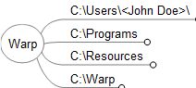

Path | Description | PATH | DPATH | LIBPATH
. |  |  |  | X
\. | Drive Root | X | X | X
\Resources | This are the multimedia shared resources like sounds, bitmaps, images that the OS uses.
\Users | This are the users directory files.
\Programs | This are the user installed programs.
\Warp | On this directory the operating system files, drivers and programs. | X | X

Warp Directory
This directory contains all the necessary files for the operating system.
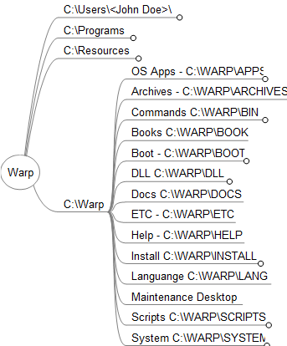

Path | Description | PATH | DPATH | LIBPATH
\Warp\AppsPM | This are the GUI applications that came embedded in the OS
\Warp\AppsCmd | The command line binaries goes here. | X | X
\Warp\AppsJava | This are the Java applications that cames with the OS.
\Warp\Archives | This is where the OS stores the “Archives” for restoring.
\Warp\Boot | The boot required drivers are stored here. Base Device Drivers. | X | X
\Warp\DLL | The DLL libraries are stored here. |  |  | X
\Warp\Docs | This directory contains the OS Programs documentations files.
\Warp\Drivers | This are other drivers used by the OS.
\Warp\Install | Installation tools
\Warp\LANG
\Warp\Archives\Maintenance Desktop | This directory contains the “Maintenance Desktop” when you boot in “Please god help me “ mode.
\Warp\Scripts | This directory contains the REXX scripts. | X | X
\Warp\System | This directory contains the system applications like MMOS2, TCP/IP, IBMCOM, etc | X | X

Users Directory
This are the directory of the files that belongs to the users of the OS.
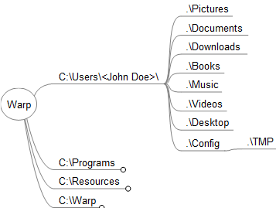
Path | Description | PATH | DPATH | LIBPATH
\Users\<user name>\Config | On this directory will go all the configuration files according to the user. Ex: Mozilla profiles, PSI profile, TEMP directory, etc.
\Users\<user name>\Config\Temp | The temporary files directory
\Users\<user name>\Config\etc | The etc directory
\Users\<user name>\Documents | Here goes the user documents Ex:ppt, odt, docx, doc, odt, xls, xlsx, ods, …
\Users\<user name>\Music | Here goes the user music files Ex:mp3, ogg, wma.…
\Users\<user name>\Videos | Here goes the user videos files Ex:mp4, mov, avi..
\Users\<user name>\Pictures | Here goes the user pictures files Ex:bmp, jpg, png

Resources
On this directory there will be stored the resources files that can be used for the operating system.

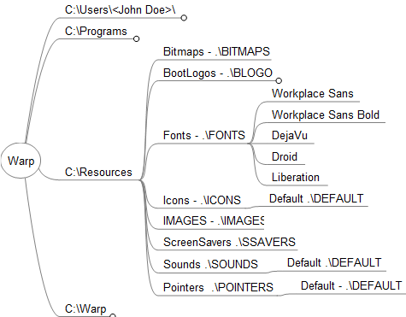
Path | Description | PATH | DPATH | LIBPATH
\Resources\Bitmaps | This are the bitmaps that are going to be shared on the OS
\Resources\Boot Logos | This are the boot logos that can be selected for the boot process
\Resources\Fonts | This are the fonts that can be used by the OS.
\Resources\Icons | The icons packs that can be used for the OS
\Resources\Images | Images to be used by the OS
\Resources\Screen Savers | Screensavers that are going to be used by the OS.
\Resources\Sounds | Sound schemes that can be used.
\Resources\Pointers | Pointers used by the OS.

Full Expanded Directory Structure Graphic.

REFERENCES

Third parties:
- http://en.ecomstation.ru/projects/developer/?action=eFDS

